Scarborough Cricket Club

Strategic Plan 2022 – 2027
August 2022

Scarborough First

From humble beginnings in 1946, the Scarborough Cricket Club (SCC) has developed and evolved into a WACA Premier Cricket Club of real substance. Our on field performances have established a Club with a proud tradition of regularly producing cricketers capable of performing strongly on the national and international cricketing stage. However, what has made Scarborough a Club like no other, is the environment that we have created off the field. Scarborough has always been a Club that is welcoming, inclusive, nurturing and most of all, ‘a home away from home’.

Our promise to our Players is that we will develop you to become the very best player that you can be – regardless of the grade. If you put in, we’ll match that effort and help you become the very best that you can be. We want to win at every Grade and as often as possible and together, we can achieve this. When your playing days are done, we want you to maintain that connection with the Club. No matter how long it is between drinks, when you want to come back to Abbett Park, we’ll be ready to welcome you home.

For our Members, we make the promise that your experience at SCC will be a positive one and that by being part of the Gulls, you are part of something special. Over the past few years, our Members have indicated that they feel that the Club has begun to ‘tread water’. The departure or retirement of junior and senior players has been higher than we’d like. Our facilities are tired and not at the standard that our proud Club expects. In addition, our Club has lost some of the ‘community minded spirit’ that has always set Scarborough apart from other WACA Clubs. Given our busy lives, it is harder and harder to find committed volunteers who are prepared to do the work that is required.

In my first year as President, I am fortunate to be supported by a highly motivated and dedicated General Committee. Together we have developed a plan for the future. The SCC Strategic Plan 2022-2027 is ‘blueprint’; that we hope will secure the future of the Club for the next 50 years. It is ambitious to be sure and if we are to achieve, it will require a truly uncommon level of dedication and commitment from everyone at our Club. I am a fan of legendary Green Bay Packers (NFL) Coach Vince Lombardi who once said;

“There is only one way to succeed in anything and that is to give it everything.”
The future is never certain and as the recent COVID-19 pandemic has taught us, our sense of order can be disrupted very quickly in this modern world.
What I can safely say to our Members, Patrons, Stakeholders, Sponsors and Supporters is that everyone that has contributed to the development of this vision for the future is up for the fight. We fully intend to succeed and because we put Scarborough First, we will give it everything. I hope that you will join us as we embark on this ambitious journey.
Best wishes,

Darren Beazley
SCC President

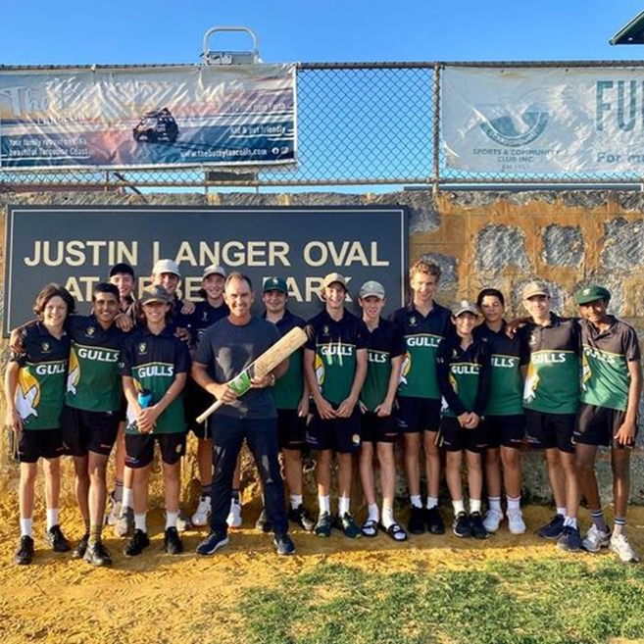

Our Vision
Scarborough is a UNITED, POWERFUL and INFLUENTIAL Premier Cricket Club with a deep connection with the cricket community and a commitment to maintaining a lasting legacy for future generations.
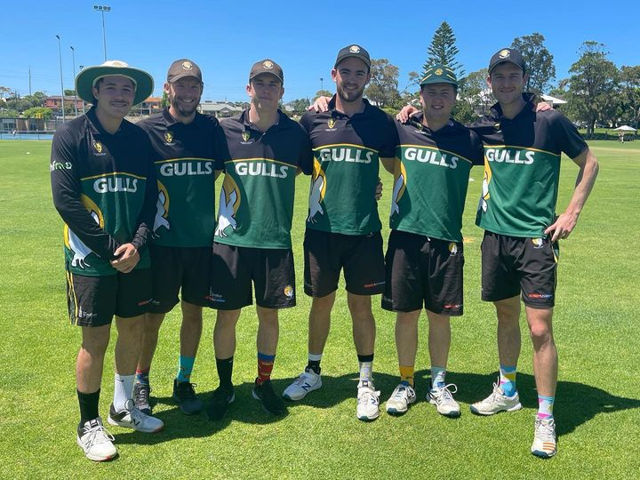

Our Mission
Through innovative approaches, establish a sustainable financial base that enables our Members to access the resources required to excel on and off the field.

Scarborough First
Around here,
the CLUB is more important than the individual.
If you are prepared to work hard, sacrifice for the advancement of our Club on and
off the ground and when your moment comes,
if you’re willing to put
SCARBOROUGH FIRST,
then this is the place for you.

Our Values
- Excellence
SCC strives to be the best possible Club in the WA Premier Cricket Competition
2. Mutual Respect
We all put “Scarborough First” and in doing so, respect differing views and options, in an environment of mutual respect
3. Accountability
We are accountable for our actions (or inaction) on and off the field
4. Integrity
SCC people always act with the highest levels of trust and honesty
5. Courage
This is an ambitious 5 year plan, but we have the resilience and courage to deliver it
6. Teamwork.
Together, we achieve more
Year One: 2022/23
Strategic Focus Areas

1st Rate Facilities | Commercial Strategy | Quality Cricket Programme | Community Engagement | Strong & Engaged Membership
Aspirations
SCC will upgrade and reinstate basic facilities | SCC will actively seek financial support | Strengthen the Coaching structure | SCC will engage, include and lead community in our District | Our Members will embrace “Scarborough First”
SCC will develop a plan for securing the long term security of the Cricket Club | Develop a plan to increase our commercial capability and financial capacity | SCC will develop a plan that increases our playing depth | SCC will give back to cricket in our District | SCC will reconnect with our Alumni to involve them in this Plan.
Key Initiatives
SCC Hard nets are upgraded | Clear commercial strategy developed | Provide high quality resources and support to SCC Coaching structure | SCC Patrons and Vice Patrons engaged and aligned with SCC Vision | Dedicated Membership Sub Committee formed
Plan and funds secured for the expansion of turf nets to 16 (winter 2023) | Increased Sponsorship | Prioritize Player Welfare via the investment in dedicated personnel and resources | Formal linkages to Community feeder Clubs established | SCC Alumni engaged and reinvigorated
SCC Scoreboard upgraded | Dedicated Fund Raising Committee established | Improved alignment of Junior programme with Senior Club | A Grade Squad engages with Community Coaches and Players | Membership merchandise range developed
Funding for SCC Master Plan schematics secured | Focus on fundraising efforts including functions and raffles | Specific development programmes developed for fast tracking talent | SCC develops a community cricket gala including various age groups | Develop a high quality SCC Members function (eg. T20 World Cup theme)
Consultation with SCC Members and Stakeholders commences |  | Development of a targeted, short term recruitment strategy
Key Performance Indicators
A whole of Club commitment to work more closely with the City of Stirling | Revenue from venue hire, sponsorship and membership increases | Retention of Players at our Club increases by 75% | In conjunction with the WACA, celebrate diversity by actively participating in inclusive events | Membership business review and benchmarking exercise completed
Repair the run up at the nets and the grass in front of the Club House | SCC secures funding through grants (eg. WACA, DSR, City of Stirling) | Single pathway philosophy embraced from Juniors through to Seniors | A Grade Squad Players will deliver one Player Appearance at a SCC Community Feeder Clubs | Improved linkages to the WACA Membership and offers
Hard nets upgraded by City of Stirling | Significant fundraising function conducted | Specific skill development programme for Colts implemented | Host a Community Club Round Robin (including a Vets Game) | Membership merchandise range developed
Install 2nd Frog Box and ensure stream is available on match day | Calendar of events and functions are affordable and inclusive of our Players and their families, friends and supporters. | 2 Club Ambassadors and Mentors (past Club greats) appointed | Develop a working relationship with The Sportsman's Club
Install two (2) tv screens in the main bar prior to commencement of season |  | Appointment of a Club Chaplain | Community Section Built onto new SCC Website
Install upgraded scoreboard/s |  | Player recruitment strategy developed and implemented (including international)
 |  | Club Medical Officer secured
 |  | All SCC Playing and Training uniforms re-designed ready for next season.

Year Two: 2023/24
Strategic Focus Areas

1st Rate Facilities | Commercial Strategy | Quality Cricket Programme | Community Engagement | Strong & Engaged Membership
Aspirations
SCC Master plan and fund raising plan endorsed by the Members and stakeholders | SCC will increase financial resources | Strengthen the Coaching structure | SCC will engage, include and lead community in our District | “Scarborough First” is part of our culture
SCC continues to upgrade and reinstate basic facilities | Expansion of revenue streams | SCC is seen as a destination Club | SCC will give back to cricket in our District | SCC Alumni support and back our Plan.
Key Initiatives
SCC Master Plan endorsed by the Members and key stakeholders | Commercial strategy gradually expanded to leverage core skills and expertise | Provide high quality resources and support to SCC Coaching structure | SCC Patrons and Vice Patrons engaged and aligned with SCC Vision | Membership Categories & benefits clearly defined
SCC Master Plan fundraising plan established | Specific Sponsorship Sub Committee established | 3 year Cricket Operations Plan developed | Formal linkages to Community feeder Clubs continue to develop | SCC Alumni engaged and reinvigorated
Recruitment of volunteers with skills and experience in Sporting Facility Project Development | Fund Raising Committee set revenue target | Complete alignment of Junior programme with Senior Club | Strategy developed to engage all of Abbett Park’s constituents (eg. dog walkers) | SCC e-commerce capability improves to move to online revenue sources
Formation of a specific Master Planning Sub Committee | Focus on fundraising efforts including functions and raffles | Development of a targeted, short term recruitment strategy | SCC develops a community cricket gala including various age groups | Community Club engagement re: SCC plans for development of Women’s cricket team
 |  | International cricket links established | Develop a positive working relationship with The Sportsman's Club | Introduction of SCC By Laws
Key Performance Indicators
A whole of Club commitment to work more closely with the City of Stirling | Revenue from venue hire and membership part of budget | Pre season trip for A Grade Squad established (e.g. Geraldton) | In conjunction with the WACA, celebrate diversity by actively participating in inclusive events | SCC Alumni help Club with fundraising efforts
SCC sight screens replaced | Grants (eg. WACA, DSR, City of Stirling) become regular revenue stream | Recruitment strategy attracts required talent to the Club | SCC Cricket (Open Day) events established | Improved linkages to the WACA Membership and offers
Upgrade & expansion of turf nets (16) | Fundraising function expands | Specific skill expansion Colts programme implemented | The Sportsman's Club actively contributing to the SCC Master Plan | Sale of SCC Membership merchandise online
Clubhouse bar facilities upgraded | Sponsorship revenue increases by 25% | First international team tour to Abbett Park to play invitational against A Grade Squad. | Potential reciprocal functions and events to engage the broader SCC Community | Introduction of a Female Membership category
Centre wicket blocks improvements | SCC Conducts cricket camps as source of revenue | Uniform Recycling Programme implemented |  | WACA supports SCC Women’s Team Plan

Year Three: 2024/25
Strategic Focus Areas

1st Rate Facilities | Commercial Strategy | Quality Cricket Programme | Community Engagement | Strong & Engaged Membership
Aspirations
SCC Master plan and fund raising plan approved by Govt. | SCC will increase financial resources | SCC Cricket Programme is high quality | SCC prominent cricket leader in our District | “Scarborough First” is part of our culture
SCC facilities continue to improve | Commercialisation of core skill set | Retention of quality players has increased | SCC will give back to cricket in our District | Focus on SCC Women’s Team
Key Initiatives
SCC Master Plan endorsed by the Members and key stakeholders | Commercial strategy gradually expanded to leverage core skills and expertise | High quality SCC Coaching and Support staff structure in place | SCC Patrons and Vice Patrons are utilised to promote the SCC Vision | Community Club engagement re: Women’s cricket team continues
SCC Master Plan fundraising underway | Major Fundraising Function now established and major revenue raiser | International cricket linkages broadened | Formal linkages to Community feeder Clubs continue to develop | SCC Alumni engaged and reinvigorated
Master Planning Sub Committee well established with sole focus on building project. | Alignment with a winter tenant to leverage investment in the bar in winter | Pathway from community cricket to SCC is being developed | Strategy developed to engage all of Abbett Park’s constituents (eg. dog walkers) | SCC e-commerce capability improves to move to online revenue sources
 | Refinement of SCC ‘Rising Stars’ Programme | Focus is now on development of home grown talent | Continue the positive working relationship with The Sportsman's Club | Review of SCC Constitution re: female teams
Key Performance Indicators
Upgrade of interior of changerooms | Revenue from venue hire and bar increases | Coaching structure now delivers the best cricket programme in WACA Premier Cricket | SCC now recruits from feeder clubs (players, coaches & volunteers) | Application to the WACA about SCC’s women’s cricket team
Minor upgrade of interior of Club House (e.g. curtains, painting, air conditioning, etc) | Grants (eg. WACA, DSR, City of Stirling) become regular revenue stream | First international pre season trip for A Grade Squad | SCC Community Cricket Day established and a major promotional event | SCC Annual Magazine established
SCC Master Plan accepted by City of Stirling and State Govt | Fundraising function expands | SCC Colts programme the best in the WACA | 4 Community Clubs better aligned with SCC | SCC Alumni help Club with fundraising efforts
Seed funding secured and major fundraising underway | Sponsorship revenue increases by 40% | 90% retention of Under 17’s graduates to Senior Cricket | SCC Patrons publicly engaged in promoting SCC Master Plan publicly | Female Membership Category expanded
Plan to have Centre wickets fully upgraded ratified by the City of Stirling | SCC ‘Rising Stars’ Programme established as new revenue stream attracting 100 participants over the year | SCC Women's Cricket strategy developed with WACA (Under 14’s) |  | WACA supports SCC Women’s Team Plan

Year Four: 2025/26
Strategic Focus Areas

1st Rate Facilities | Commercial Strategy | Quality Cricket Programme | Community Engagement | Strong & Engaged Membership
Aspirations
SCC Building Project Underway | SCC will increase financial resources | SCC Cricket Programme is high quality | SCC prominent cricket leader in our District | “Scarborough First” is part of our culture
SCC Cricket facilities of high standard | Commercialisation of core skill set | SCC Influence is beyond WA | SCC major part of the community | Focus on SCC Female Members
Key Initiatives
Construction commences on new building | Commercial strategy well established | SCC Female Team Coaching and Support staff structure in place | SCC Patrons and Vice Patrons publicly promote the SCC Vision | SCC Alumni assist Club with fundraising efforts
SCC Master Plan fundraising underway | Major Fundraising Function now established and major revenue raiser | International cricket links leveraged | Formal linkages to Community feeder Clubs continue to develop | SCC Family Membership Category introduced
Master Planning Sub Committee well established with sole focus on building project. | Alignment with a winter tenant to leverage investment in the bar in winter | Pathway from community cricket to SCC is being developed | Continue the positive working relationship with The Sportsman's Club | SCC Historian identified and appointed to write the history of SCC
Key Performance Indicators
Ground for Female Team secured | SCC Reserves reach $500K | Female Team Coach appointed | Pathway from Community cricket to SCC clearly identified | Hall of Fame concept introduced
Centre wicket blocks refurbished | Grants (eg. WACA, DSR, City of Stirling) become regular revenue stream | International Teams tournament established | Patrons assisting in securing govt funding for building project | SCC Membership over 150
Project builder appointed | Fundraising function expands | SCC Wins Champion Club award | 4 Community Clubs better aligned with SCC | SCC Alumni help Club with fundraising efforts
Major fundraising continues | Sponsorship revenue major component of Club funds | 90% retention of Under 17’s graduates to Senior Cricket | SCC Patrons publicly engaged in promoting SCC Master Plan publicly | Female Membership Category expanded
 | Building Project 75% funded | SCC Women’s Team introduced | SCC Community Cricket Day expands to community venues

Year Five: 2026/27
Strategic Focus Areas

1st Rate Facilities | Commercial Strategy | Quality Cricket Programme | Community Engagement | Strong & Engaged Membership
Aspirations
SCC Building Project Completed | SCC will increase financial resources | SCC Cricket Programme sets the standard | SCC prominent cricket leader in our District | “Scarborough First” is part of our culture
Abbett Park is destination to watch and play cricket | Commercialisation of core skill set | SCC | SCC major part of the community | Focus on SCC Female Members
Key Initiatives
Construction on new building completed | Commercial strategy well established | SCC Female Team Coaching and Support staff structure in place | SCC Patrons and Vice Patrons publicly promote the SCC Vision | SCC Alumni assist Club with fundraising efforts
SCC Master Plan fundraising continues | Major Fundraising Function now established and major revenue raiser | International cricket links leveraged | Affiliates of SCC expand SCC’s influence | SCC Family Membership Category introduced
Master Planning Sub Committee concludes project | Alignment with a winter tenant to leverage investment in the bar in winter | Pathway from community cricket to SCC is being developed | SCC Community Cricket Day developed to expand SCC impact | SCC Historian identified and appointed to write the history of SCC
Key Performance Indicators
Ground for Female Team secured | SCC Reserves reach $500K | SCC delivers the best cricket programme in WACA Premier Cricket | Pathway from Community cricket to SCC clearly identified | Annual Hall of Fame dinner and inductees
Continued maintenance of turf nets | Strong social media platform | International Teams tournament contunues | Patrons have secured govt funding for building project | SCC Membership reaches 200
Major fundraising continues | Fundraising function expands | SCC Wins A Grade Premiership | Diversity strategy developed | SCC Alumni help Club with donations
 | E-commerce now drives revenue sources | International pre season trip for A Grade Squad established | SCC Patrons publicly engaged in promoting SCC Master Plan publicly | History of SCC written
 | Building Project 100% funded | 2nd SCC Women's Cricket team introduced

Today

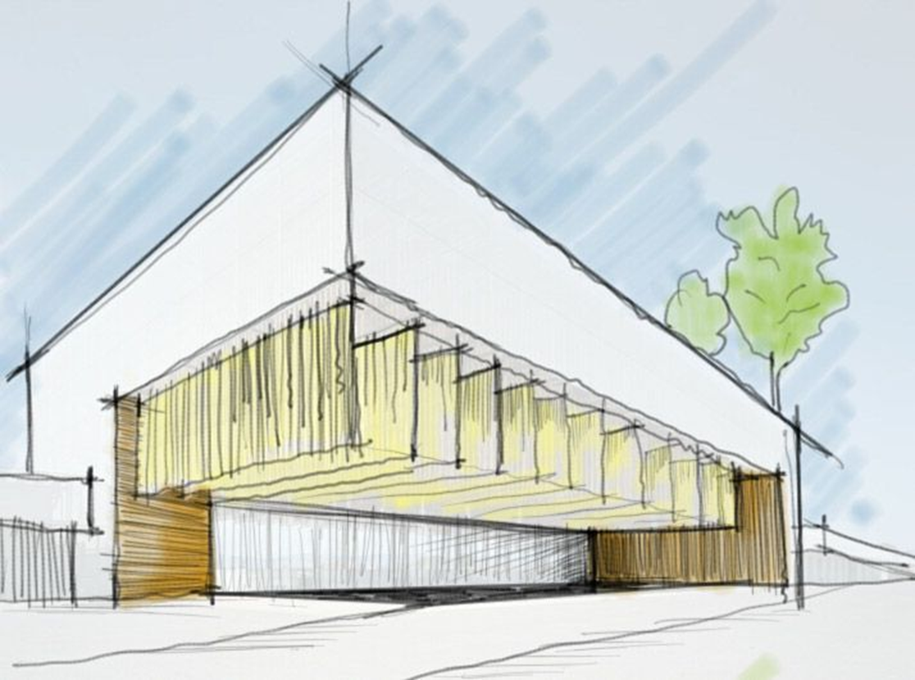
Our Goal

